THE BRITISH CHAROLAIS CATTLE SOCIETY LTD HERD/SALE HEALTH DECLARATION
UK HOLDING NUMBER HERD PREFIX
NAME

ADDRESS

SALE DATE Friday 31st of May 2019
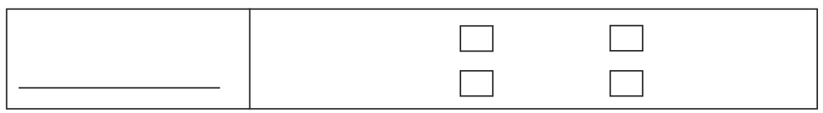
TB
DATE HERD LAST TESTED TESTING INTERVAL 1 YEAR 2 YEAR

3 YEAR 4 YEAR

CHeCS Health Scheme Membership (please tick)
SAC Premium Cattle Hi Health AFBI Cattle Herdsure
Health Scheme Herdsure (Biobest) Health Scheme (VLA)

Other (please name)
PLEASE COMPLETE

ACCREDITED MONITORED HERD BVD ANTIGEN VACCINATION OF DATE OF
FREE TESTING TEST SALE ANIMALS VACCINATION
(This is compulsory
if member not
accrediteda
Health Scheme)
BVD YES Compulsory / /
NO

IBR YES specify / /
Whether IBR
NO marker vaccine

LEPTO YES / /
NO
JOHNES RISK LEVEL (1- 5)

Vendor Declaration:
I certify that the above information is correct as at date of entry and permit the BCCS to verify the details with the
Relevant CHeCS Health Scheme. The responsibility for the accuracy of the information rests solely with the breeder and not with the British Charolais Cattle Society Ltd.

Signed: Name: Date:
If the herd is not CHeCS accredited for BVD a BVD Antigen Test MUST be taken and a copy of the certificate MUST be taken to the sale and given to the auctioneers.

ENTRIES CLOSE ON FRIDAY 12th of APRIL 2019

